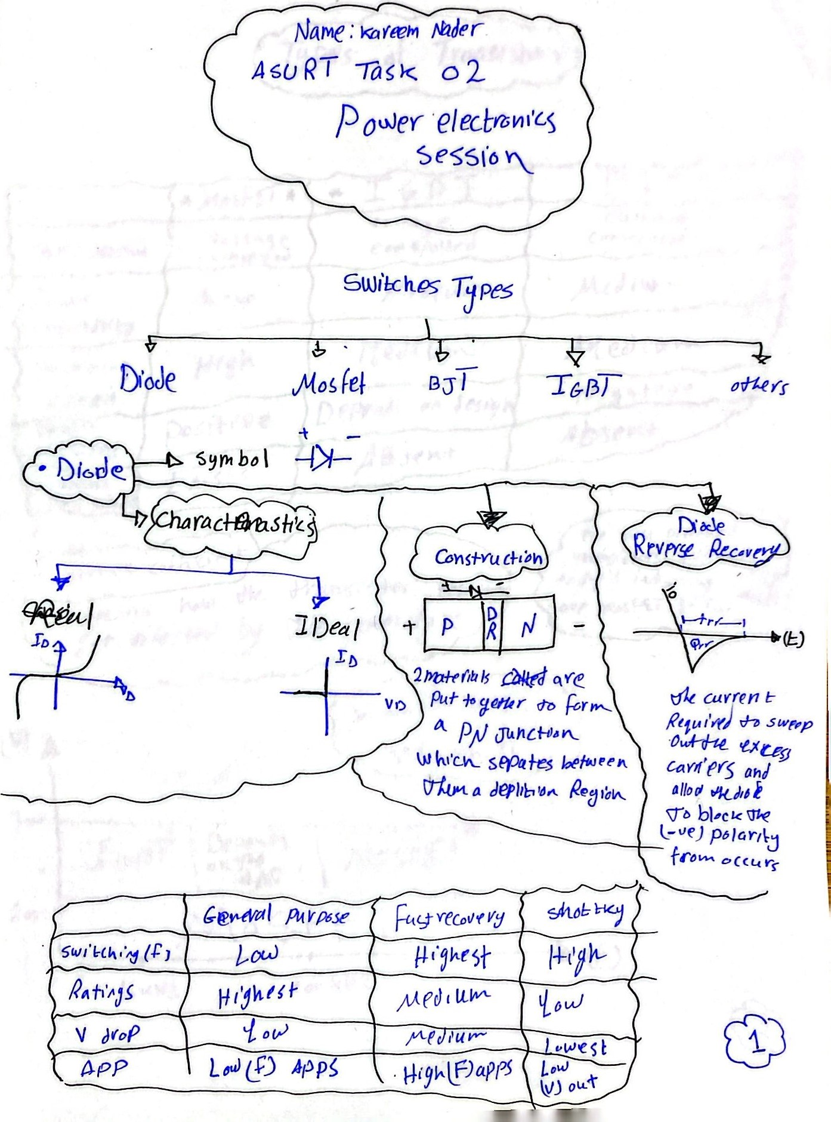



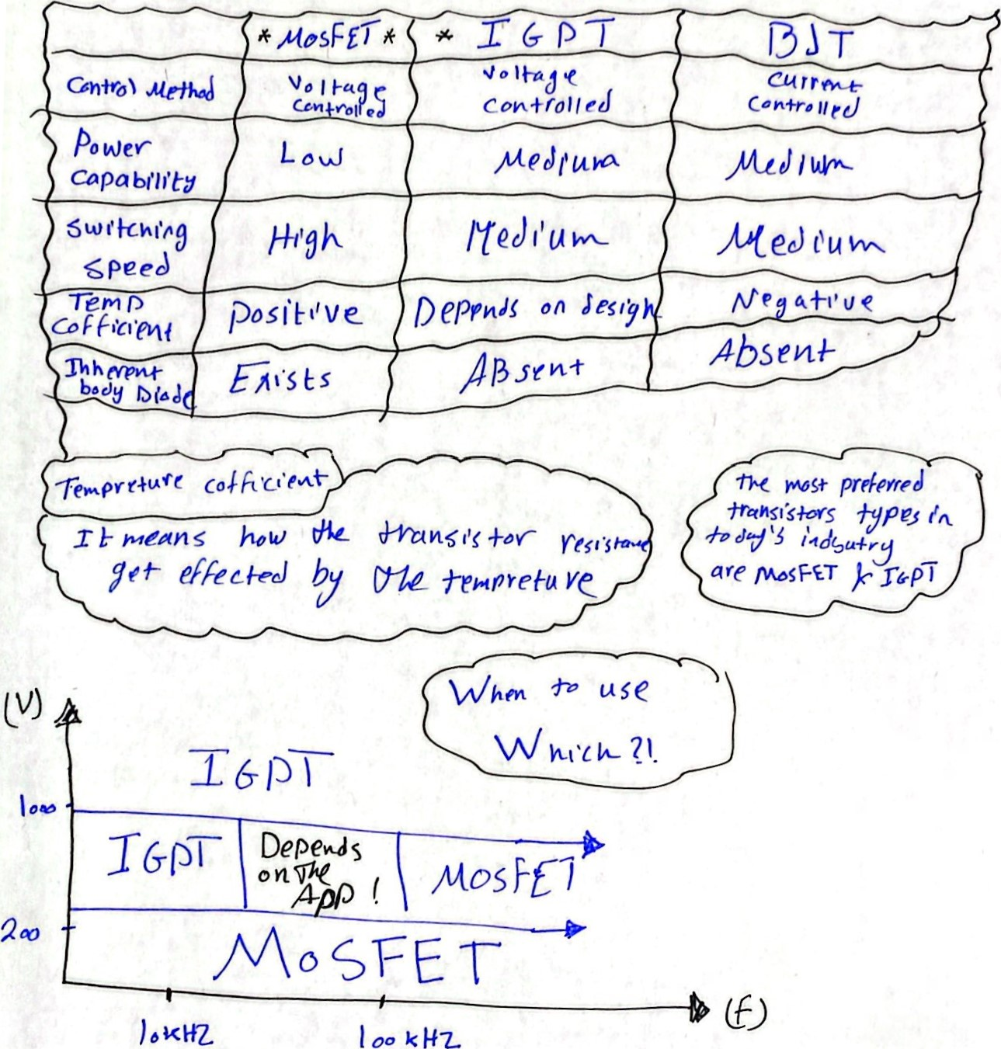

k

00

# 2. The other MOSFET

I found that STP55NF06L power transistor is more better than the MOSFET used in the video because of:

1. Higher Id up to 55 A instead of 50
2. Higher Vds up to 60 V
3. Lower Rds on up to 0.02 ohm